Abstract and presentation title:
The role of RNPAs in improving cybercrime reporting in Scotland
Author:
Sikra, J.
Affiliation:
University of Strathclyde, Taras Shevchenko Kyiv National University
Background: The Scottish neoliberal government’s enlisting of community and private sector organisations in economic cybercrime reporting is a form of responsibilisation. These organisations collect, evaluate and forward victims’ cybercrime reports as state intelligence. I pioneer the term Responsibilised non-policing agencies (RNPAs) to unmask the genealogy of their acquired role. Methods & Analysis: I interviewed and compared Scottish (N=11) versus Italian (N=4) RNPAs to understand responsibilisation internationally and improve cybercrime reporting nationally. Scottish RNPAs are state-sponsored charities, banks, regulators of commerce and private institutions. Italian RNPAs are private law firms. All were represented by their relevant functions. Results: In Scotland, RNPAs form a responsibilisation buffer zone between the state and victims (see: Figure 1.). The Scots state exports selective funding and catholic responsibility to RNPAs and imports cybercrime intelligence. The Italian state is comparatively disengaged. Victims risk criminal responsibilisation, which is why they turn to RNPAs. Discussion: Scottish RNPAs supply an opportunity cost dilemma. The state can keep using RNPAs to narrate an improving cybercrime reporting strategy, which is cheaper. Alternatively, the state can restructure the funding of select RNPAs and increase funding for specialised cybercrime policing, which is more expensive. Conclusion: Both options are viable with specialisation bearing the opportunity cost.
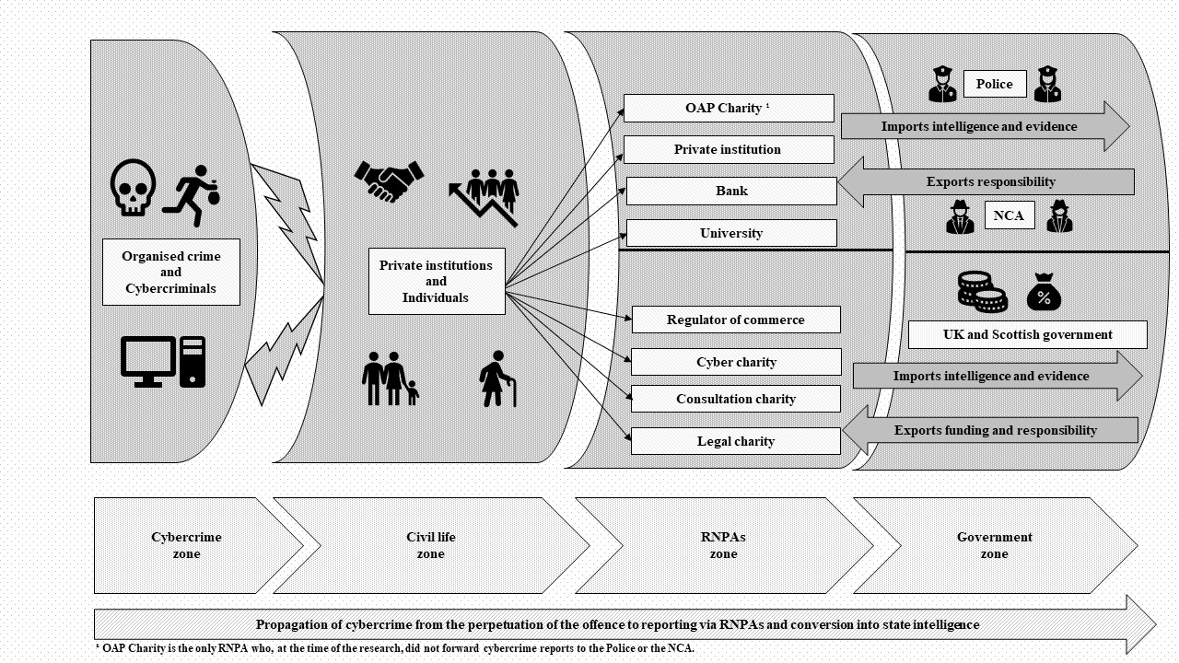
Figure 1.

